Docker-1
- Setup a virtual machine using Ubuntu image.
- First lets launch new instance
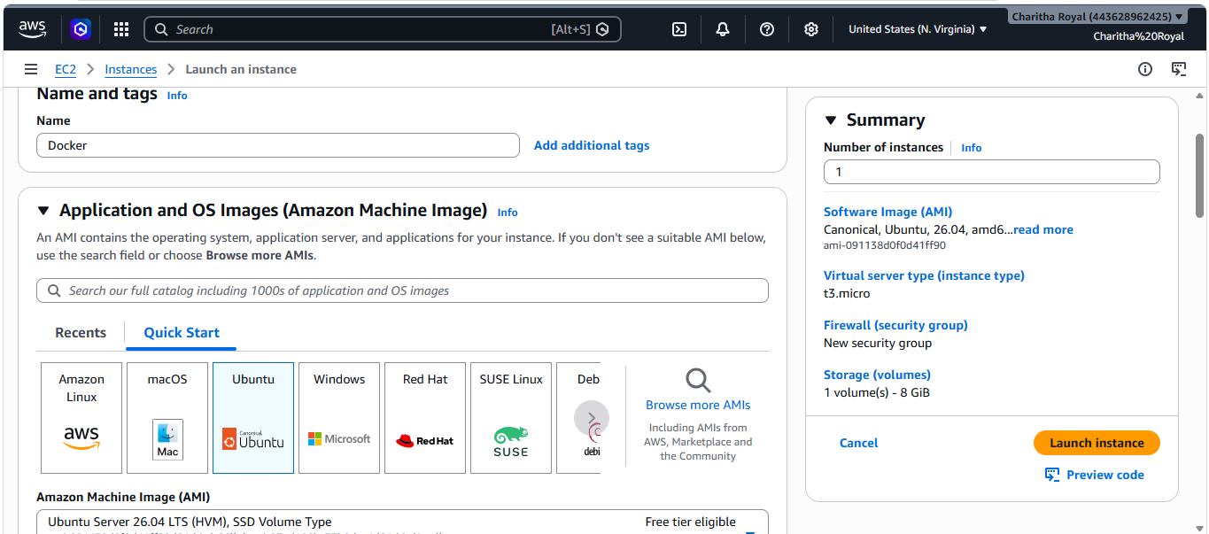
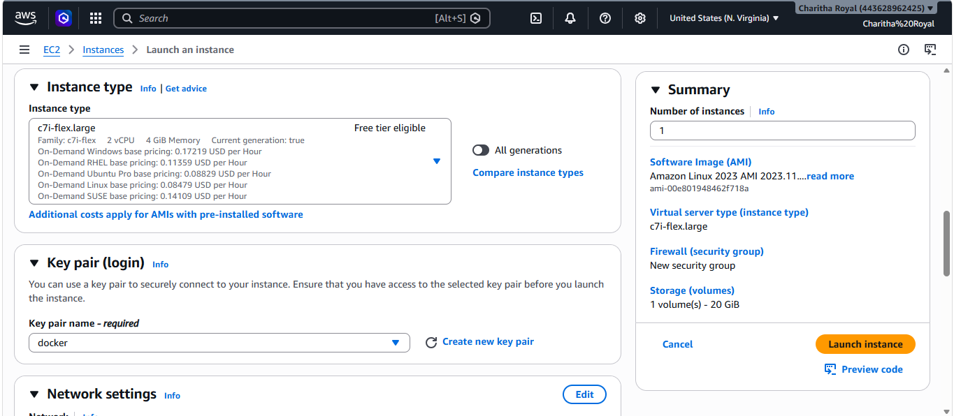
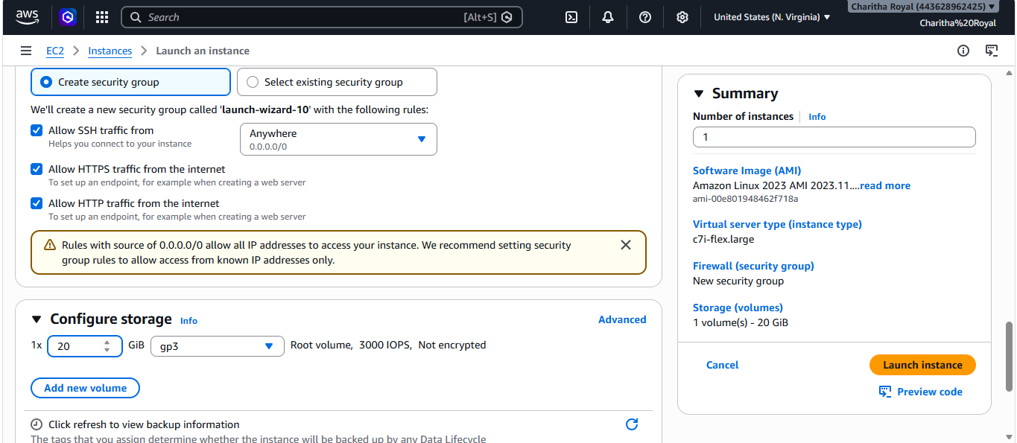
- Connect to instance
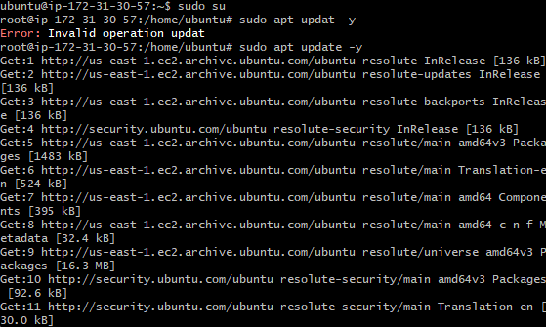
- Install docker on ec2.
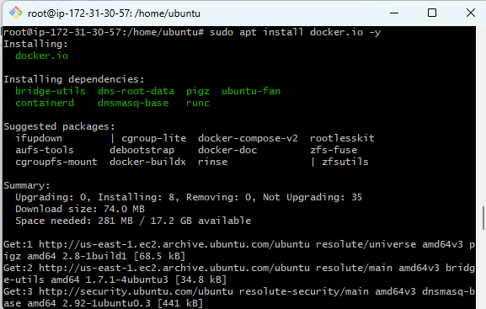
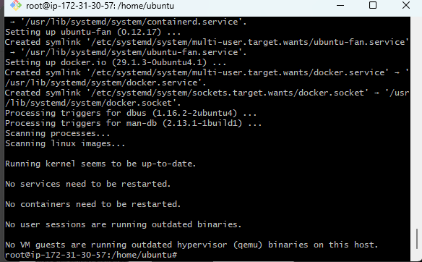
- Pull 5 docker images. (nginx, Apache tomcat, ubuntu, Jenkins, SonarQube)
- To pull docker images
- For nginx – docker pull nginx
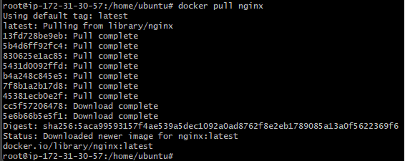
- For tomcat- docker pull tomcat
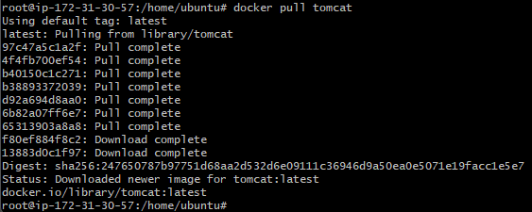
- Ubuntu : docker pull ubuntu
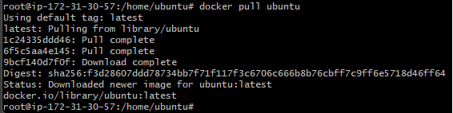
- Jenkins : docker pull jenkins/jenkins:lts
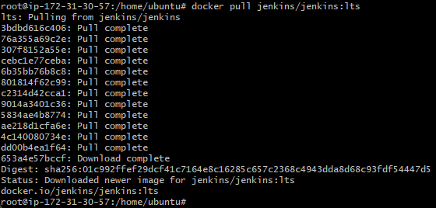
- Sonarqube - docker pull sonarqube
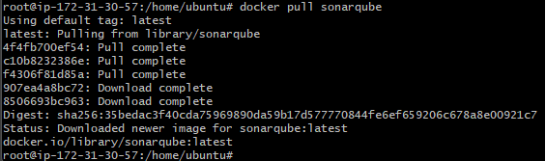
- To verify
- docker images
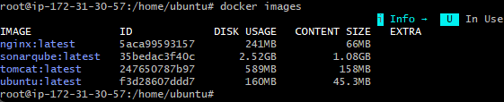
- Run nginx container and expose on port 81.
- Run container
docker run -d --name nginx-container -p 81:80 nginx
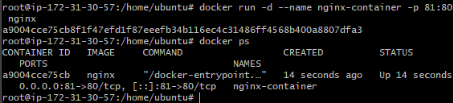
- Verified in browser
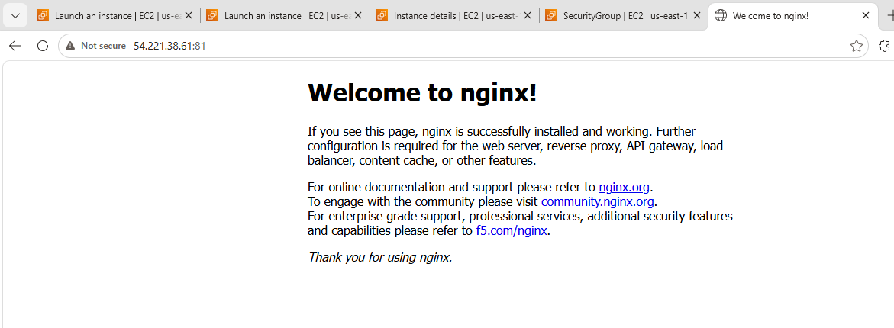
- Delete the Apache tomcat image from local.
- First lets check docker images

- Deleted tomcat image and verified
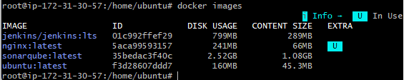
- Inspect the Jenkins image, SonarQube image.
- Inspect Jenkins image
docker image inspect jenkins/jenkins:lts
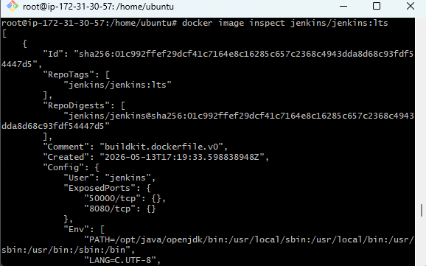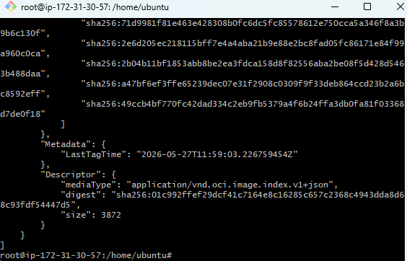
- Inspect sonarqube image
docker image inspect sonarqube
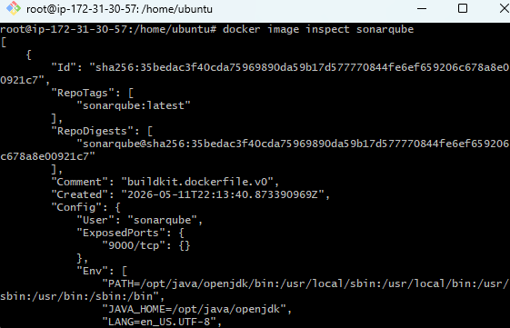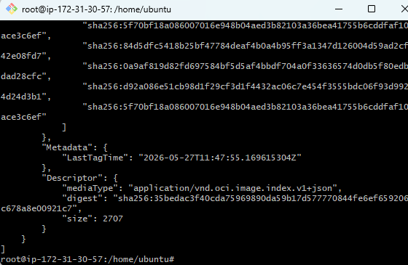
- Run Jenkins container and run one sample job.
- Run Jenkins
docker run -d \
--name jenkins-container \
-p 8080:8080 \
-p 50000:50000 \
jenkins/jenkins:lts
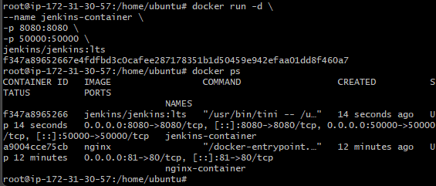
- Access Jenkins
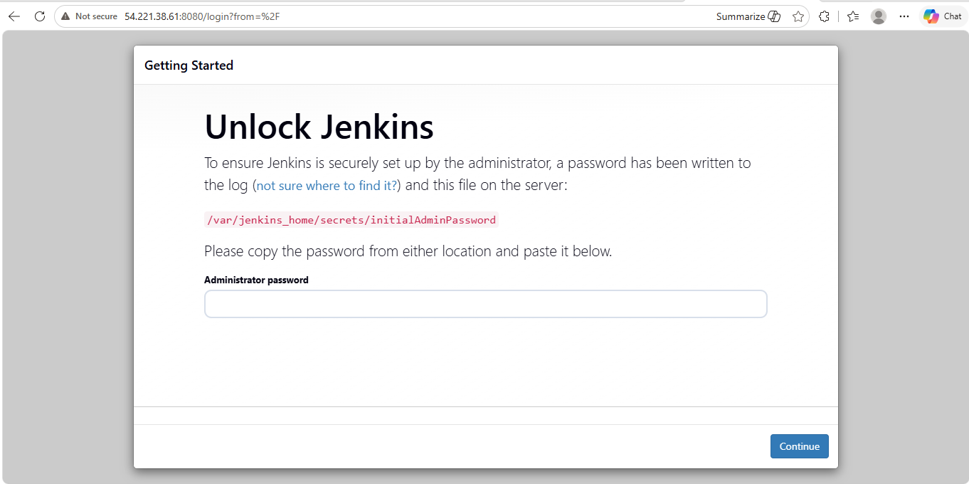
- To get Jenkins Initial Password
docker exec jenkins-container cat /var/jenkins_home/secrets/initialAdminPassword
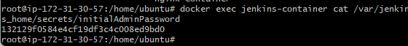
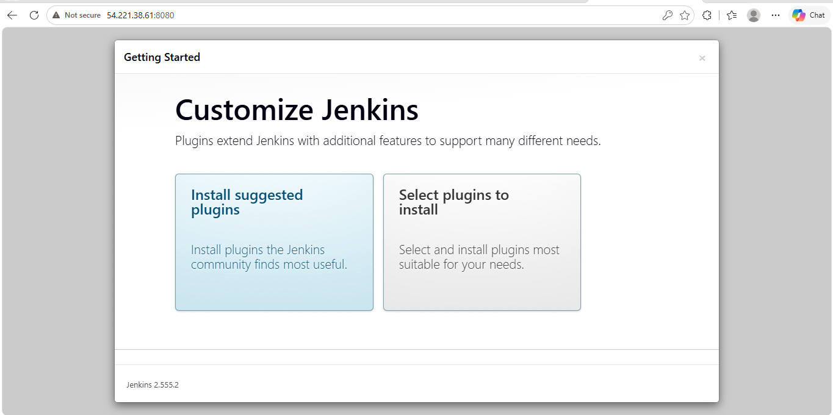
- Create user and password
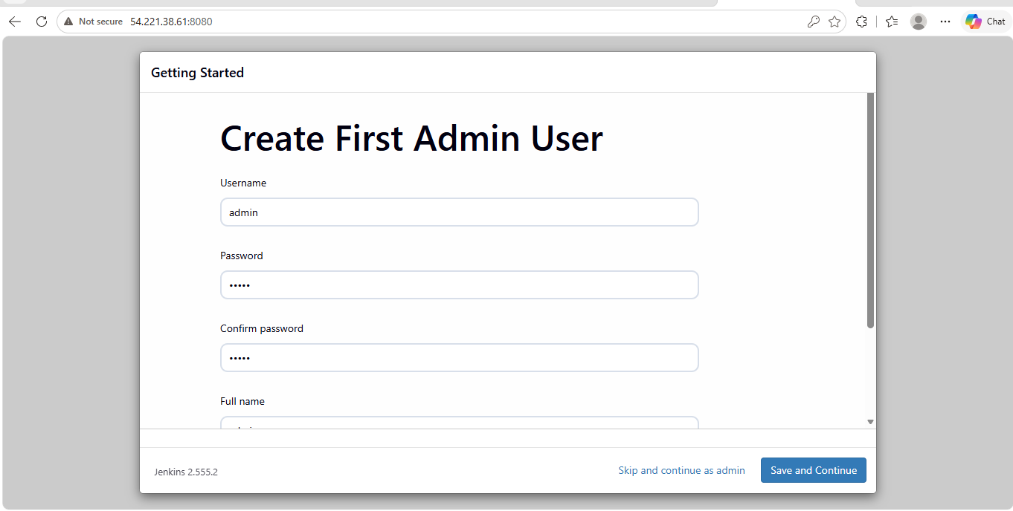
- Now lets create a new item
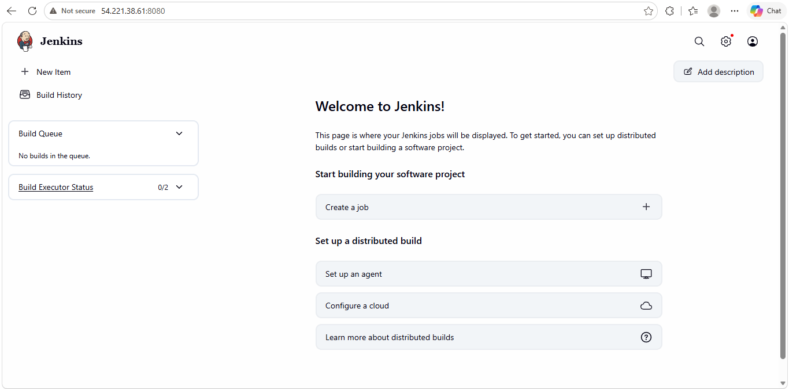
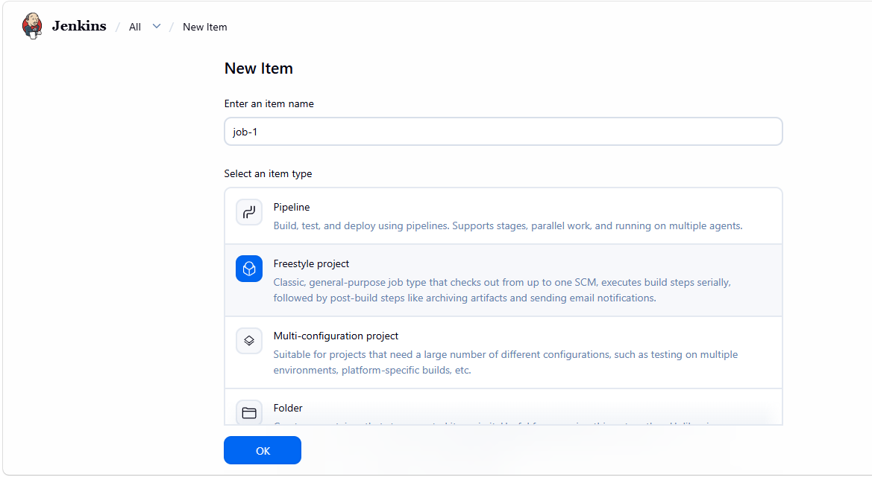
- Choose execute shell
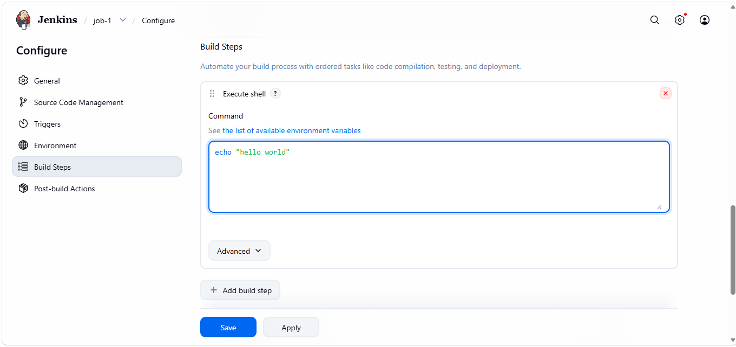
- Click on build now to run the job
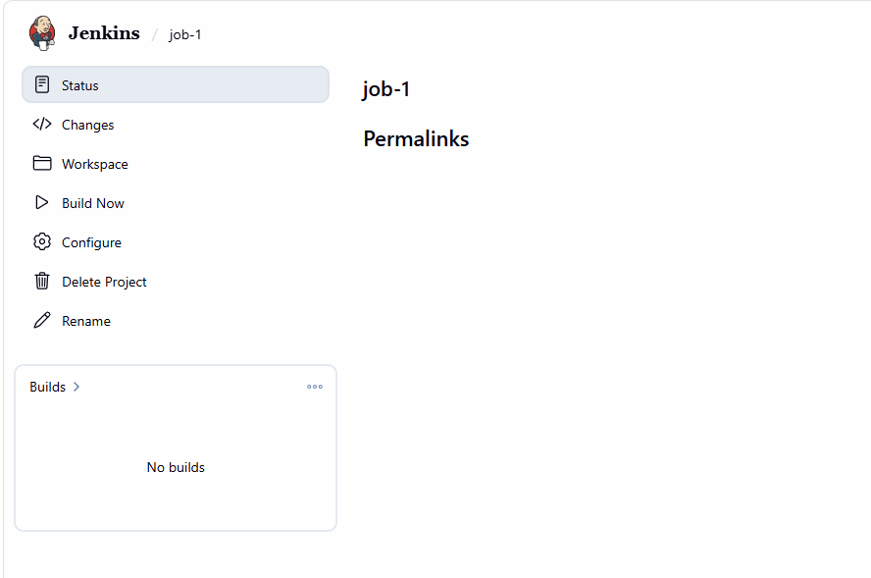

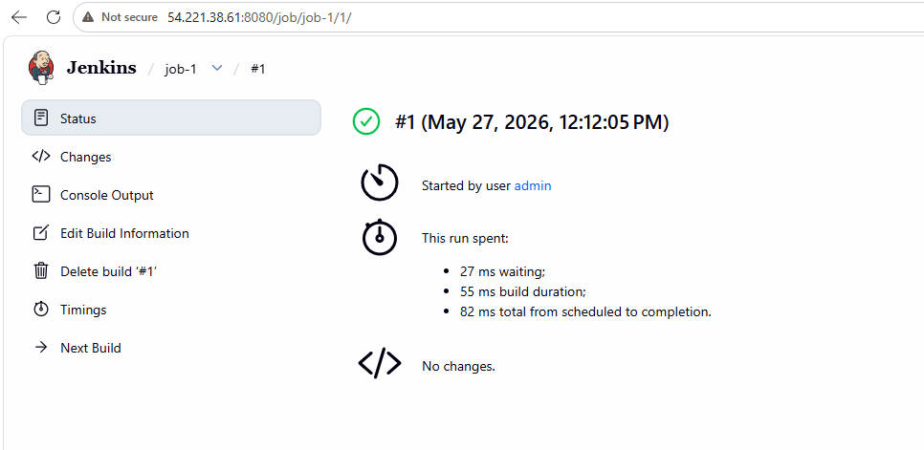
- Check the console output
